ADVERTISEMENT
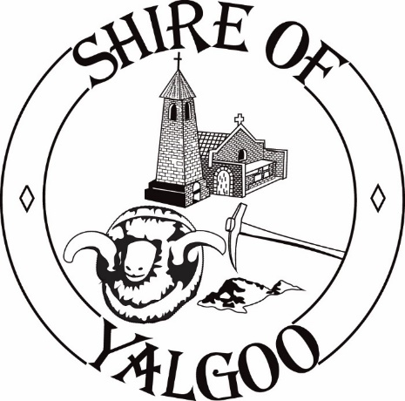 | Deputy Chief Executive Officer  Corporate & Community Services

Do you want to join a small but dynamic team, support the recently appointed CEO, take up the challenges of this newly created position, and make a lifestyle change in regional Western Australia…….then please consider this role!!!

This is an excellent opportunity for an enthusiastic and experienced professional to lead the corporate and community services team for the Shire of Yalgoo and support the CEO to deliver the Council’s strategic and corporate objectives.

The role will lead and manage the daily operations of the Shire to ensure that the finance, administration, information technology, customer service and community services functions are delivered effectively and efficiently. Strong financial management skills are key to ensure accurate and timely financial and management reports to Council including the preparation of the budget and Annual Report. This role will also require you to have a sound understanding of Community Services and how the services impact on the Community to ensure services are delivered to the standards and expectations of the Community and Council.

A three (3) to five (5) year performance based fixed term contract is offered with an attractive remuneration package will be negotiated with the successful applicant, of between $108,775 - $125,950 per annum plus regional / isolation allowance (refer information package). Salary and benefits are subject to negotiation and include, base salary, superannuation, accommodation, motor vehicle, utilities allowance and a professional development allowance.

To be considered for this role position you must obtain Candidate Information Package and address the Selection Criteria. To obtain a package please email wa@logoapp.com.au or contact Sylvana Caranna, Executive Recruitment Consultant, LO-GO Appointments on 0405 307 139 should you require further information.

Applications close at 5:00pm on Monday, 24 May 2021

Canvassing of Councillors will disqualify
